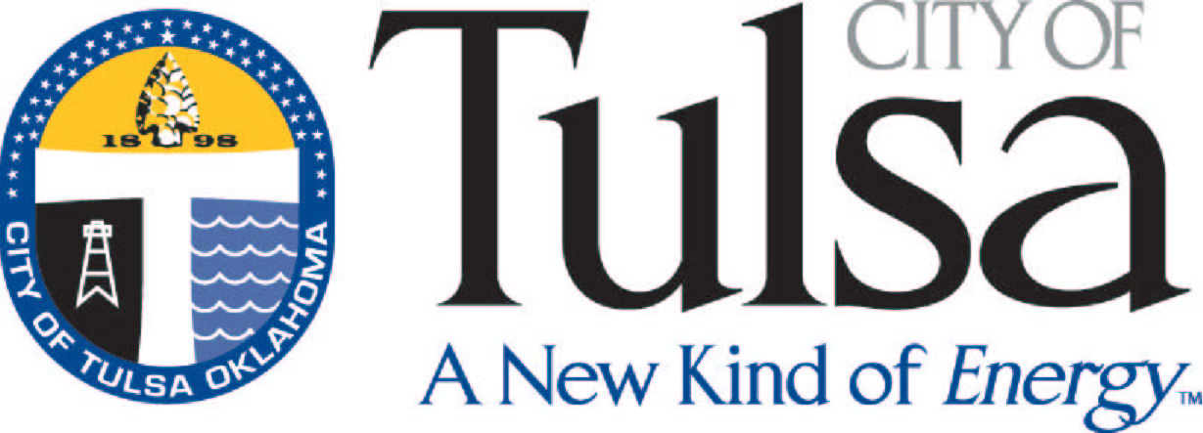
CITY OF TULSA
License Center – (918) 596-7640

New License Checklist

The City of Tulsa licenses required for a new restaurant/bar/food cart are listed below, including the documents required to obtain the licenses.

Occupational (City of Tulsa alcoholic beverage license) –
The ABLE commission requires a “Certificate of Compliance” prior to issuing your ABLE license – if this is required for your business, please contact Business Licensing at (918) 596-7640 (or you may print the information at the website:
https://www.cityoftulsa.org/COTlegacy/documents/ComplianceCertificateApplication.pdf
Once the ABLE license has been issued, the documents required to obtain the City of Tulsa Occupational Tax Permit are as follows:
- Oklahoma Sales Tax Permit (918) 581-2399
- Updated Certificate of Use and Occupancy (Zoning Clearance Permit) – for new issuance or change of use ONLY. Please call the Certificate of Occupancy Coordinator with questions (918) 596-1847
- ABLE license (405) 521-3484
- Fee (applicable by license type, prorated monthly)

Food –
- Oklahoma Sales Tax Permit (918) 581-2399
- Original “Blue” Food Application from TCC Health Department – (918) 595-4300
- License Fee (as stated on Food Application)
- Late Fee, a penalty of 50% will be added to the license fee after30 days from the issued date on the blue food application

Sales Tax Permit, and ABLE license must be current.

DBA Name, Corporate Name and site address must match on all documents submitted.

Copies of all documents EXCEPT FOOD APPLICATION are acceptable.

